***Project Name – LAKME***

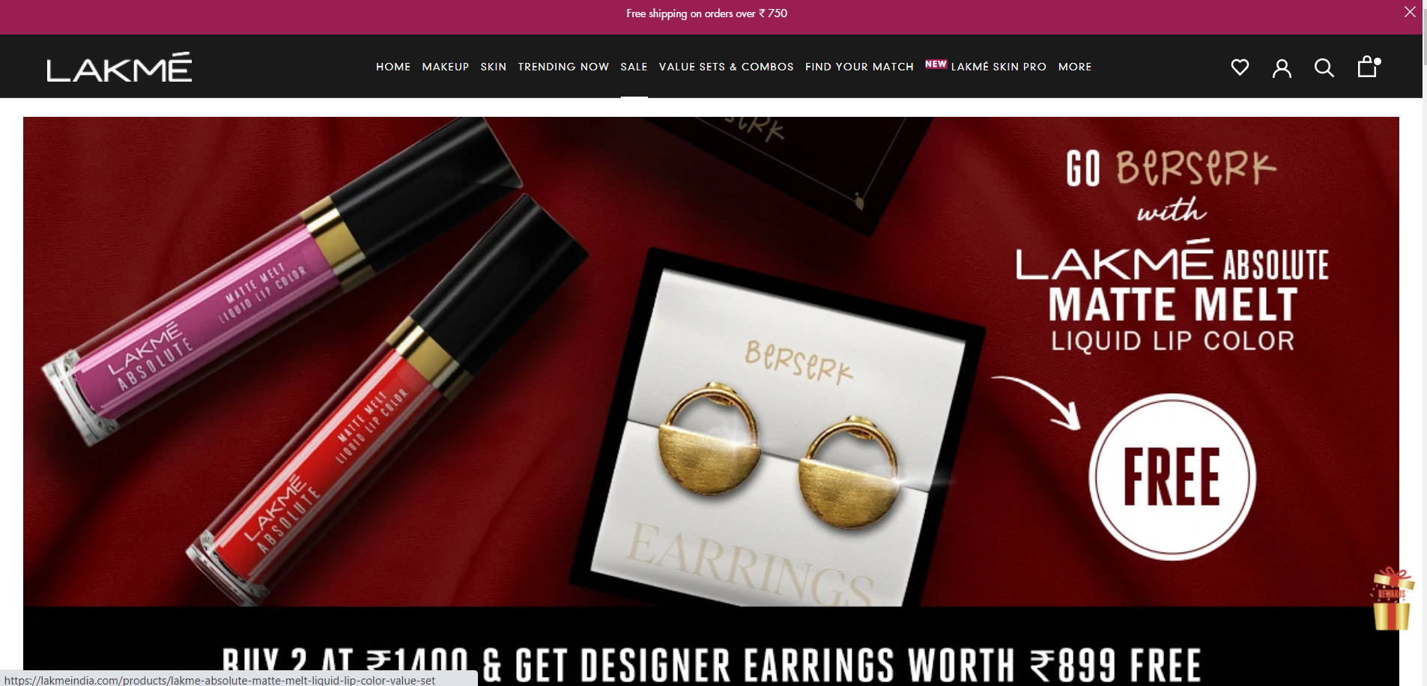

|  |  |  |
| --- | --- | --- |
| **By** | | |
| **Asama Sande** | **Edureka** | **28th  Dec.2021** |

**Overview**

**"AN ALLY TO THE CLASSIC INDIAN WOMAN, LAKMÉ INSPIRES HER TO EXPRESS THE UNIQUE BEAUTY AND SENSUALITY WITHIN… ENABLING HER TO REALIZE THE POTENCY OF HER BEAUTY."**  
  
The contemporary Indian beauty expert - Lakmé continuously innovates to offer a wide range of high performance and world class cosmetics, skincare products, and beauty salons. Combining international cosmetic technology with an in-depth understanding of the Indian woman’s needs, Lakmé also offers its consumers a comprehensive beauty experience through its products that are ideal for a variety of Indian skin tones.

**Goals/Pages**

**NAVIGATION ON BAR (TOP)**

* **Lakme Logo**
* **Home Makeup, Skin, Trending Now, Sale, Value, Sets & Combos, find you match, Lakme Skin Pro, max**
* **Wish list**
* **Account**
* **Search Bar**
* **Cart**

**MENU BAR**

* A Horizontal division bellow navigation bar where different categories of products are available to see

**ADVERTIESMENTS AND OFFERS AND BANNER SECTION**

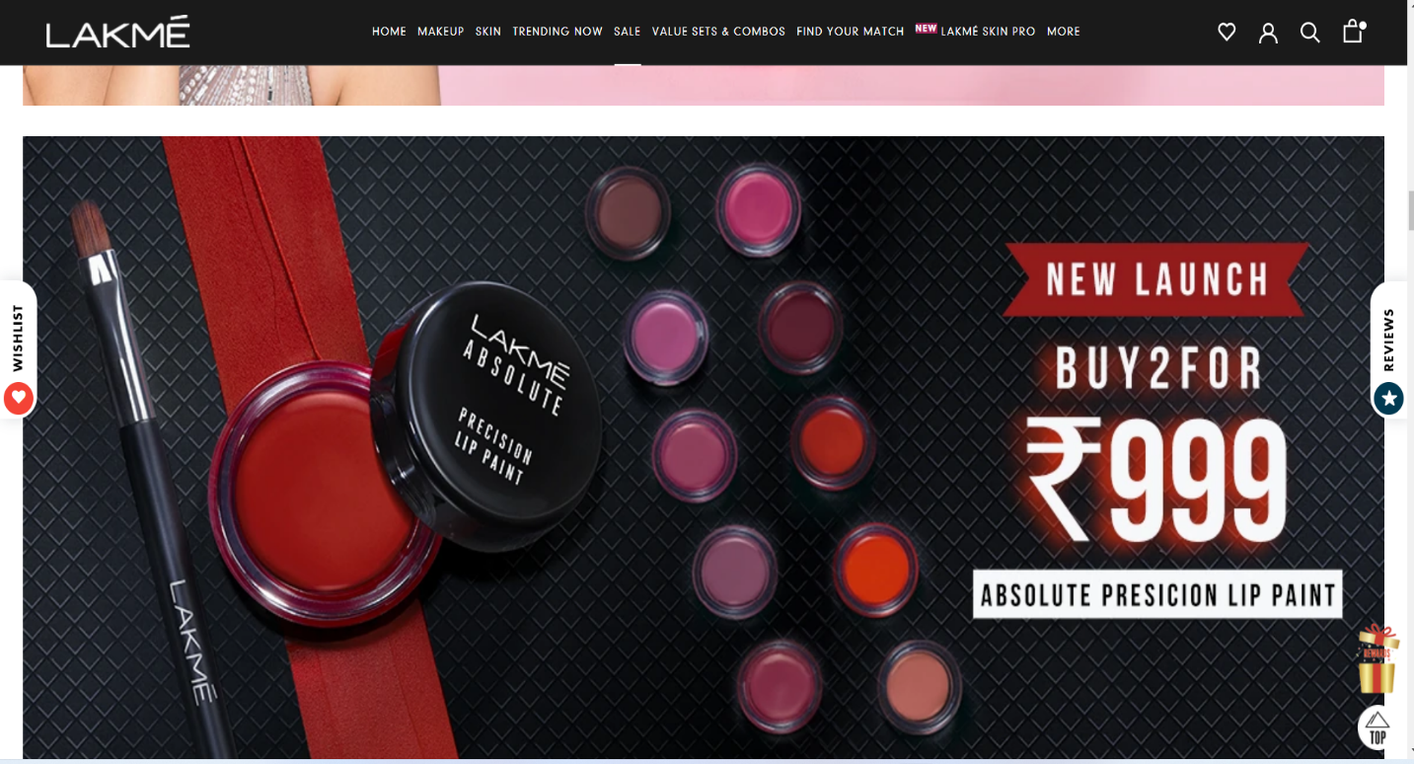

**VIEW ALL PRODUCTS**

* List of Products with image by category(Clickable)

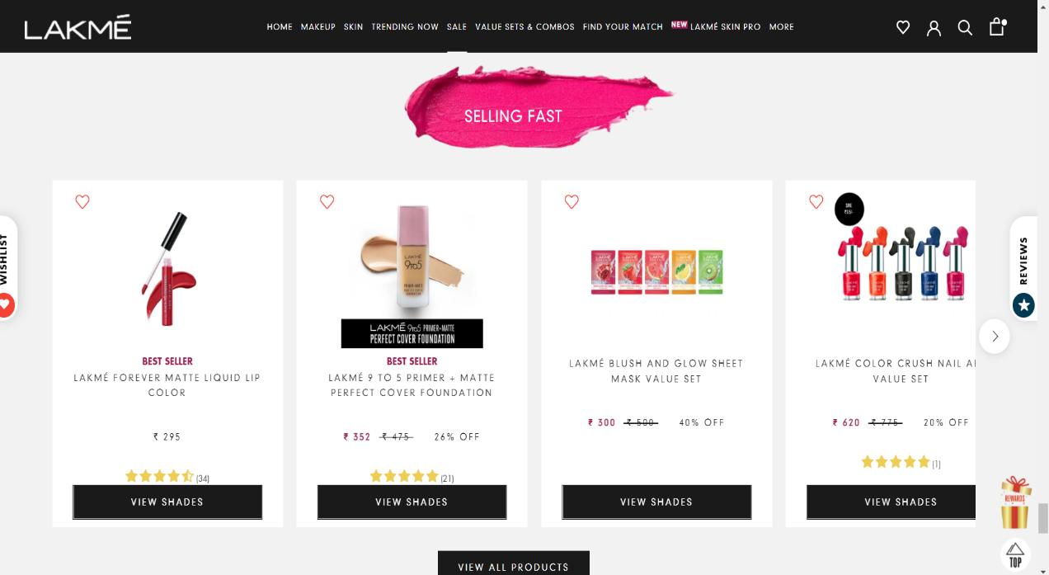

**ON CLICK**

* Option to buy and add to cart or wish list
* Increase the quantity of item
* Details, How to use
* Discount offer if Available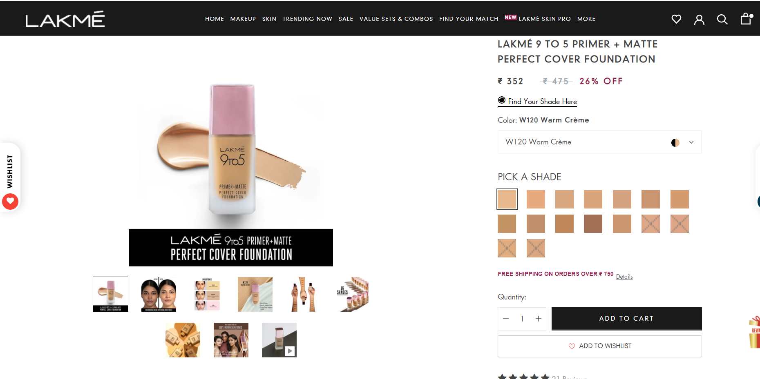

**INFORMATION / PAYMENT**

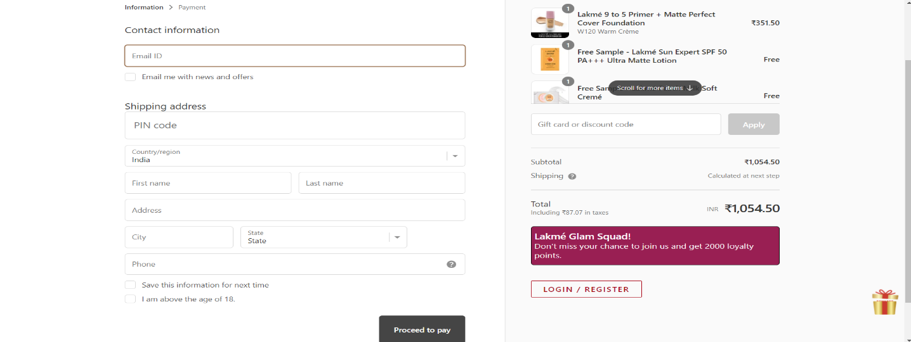

**Technology used in Instagram**

**Front-End: -**

* **Html**
* **Css**
* **Bootstrap**
* **React**

**Dynamic: -**

* **JavaScript**

**Database: -**

* **MongoDB**
* **Json Data**

**Code Compilers: -**

* **Visual Studio Code**
* **Git Bash**
* **Git Hub**
* **Node Js.**

**Referance Site**

[**https://www.lakme.com/**](https://www.lakme.com/)

**Github Link**

**https//github.com/Asamadeveloper786/Documentation_Project-2.git**